89.06.00c
To the Gardeners' Chronicle

[Our illustration (p. 105) exhibits a primitive mode of forming a bridge by felling a huge Eucalyptus, and allowing the trunk to fall over a ravine of considerable width, in Gipp's Land, Lachland Territory, New South Wales. Baron F. Von Mueller, to whom our thanks are due for forwarding the photograph from which the figure was engraved, and which also shows a noble Tree Fern (Dicksonia), in writing to the Argus in March last, from South Yarra, concerning the big trees of Victoria, remarks : — ]

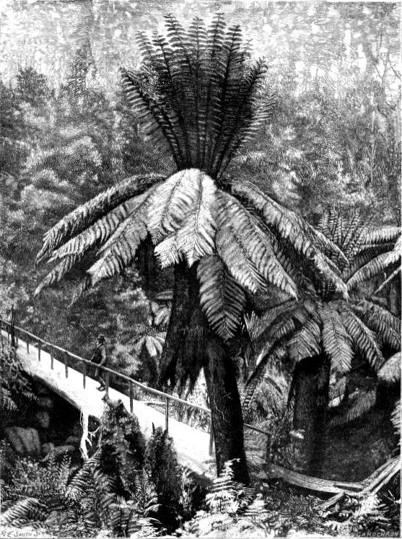

Dicksonia
Eucalyptus

Letter not found. For the text given here, see 'Tree bridge over a ravine', Gardeners' chronicle, 27 July 1889, p. 107. It is dated to June as the latest likely date that it could have been sent to have been reported in this issue.
89-06-00c_image01.jpg The illustration is captioned 'Fig. 16—A tree bridge in Gippsland, New South Wales'.
'Lachland Territory' has not been identified; Gippsland is an eastern region of Victoria.
Misreading of May?
The remainder of the article is a transcription of M to the Editor of the Argus, 23 May 1889, i.e. B89.05.01.

